Executive Summary: AI-Supported Healthcare Database Analytics

Introduction and Business Context
This project developed an AI-supported database analytics approach using the Hospital Data for Patient Readmission Prediction dataset obtained from Kaggle (Sharma, no date). The source contained 10,000 observations across 26 variables representing patient demographics, hospital activity, clinical information and resource utilisation. Initial exploration identified 6,022 distinct patient identifiers, while 4,142 records, representing 41.42% of the dataset, were marked positively by the supplied readmission variable.
The client was considered to be a hospital healthcare organisation requiring reliable patient and operational intelligence for service planning and resource management. The main requirement was to transform the flat dataset into a structured analytical environment supporting analysis of readmissions, waiting times, length of stay, diagnoses, ward activity and capacity while retaining visibility of data-quality issues. A relational approach was selected because appropriately normalised databases reduce unnecessary duplication and improve consistency by separating information into related entities (Silberschatz, Korth and Sudarshan, 2019; Elmasri and Navathe, 2022).
The project combined generative AI, Python/Pandas, relational database modelling, SQL and business-intelligence visualisation. AI was used as a development aid rather than as an autonomous decision-maker, with generated recommendations and code subjected to programmatic and human validation.

AI-Supported Development Methodology
A staged methodology was adopted to ensure that data quality was assessed before analytical outputs were produced:
Source data → AI-supported schema and data profiling → Python validation → cleaning and transformation → feature engineering → relational modelling → SQL analysis → interactive dashboard.
Building on the Unit 6 team project, my individual evaluation focused on reviewing the proposed database design, assessing AI-assisted Python profiling and validation, and interpreting the analytical outputs against the client's requirements. ChatGPT supported schema identification, while Gemini in Google Colab assisted with Python code generation. Generated outputs were reviewed and validated rather than accepted without verification.
AI can accelerate schema alignment, integration and cleaning, while programmatic methods can validate its suggestions (Dong and Rekatsinas, 2018).

AI-Assisted Schema Identification and Relational Design
ChatGPT examined source field names, data types and business meaning to identify candidate entities, attributes, keys and relationships. Its proposed schema was reviewed against the source data and relational database principles before adoption. Encounter was selected as the central transactional entity, with separate Patient, Hospital, Ward, Doctor, Specialty, Diagnosis and ReferralDepartment entities. EncounterDoctor and EncounterDiagnosis represented many-to-many relationships, while WardCapacitySnapshot captured time-varying capacity. The source data did not contain a dependable encounter identifier. A generated EncounterID was therefore used within the relational design, while a RawRowID maintained traceability to the original record. This was considered safer than assuming that an existing source field represented a reliable unique key.
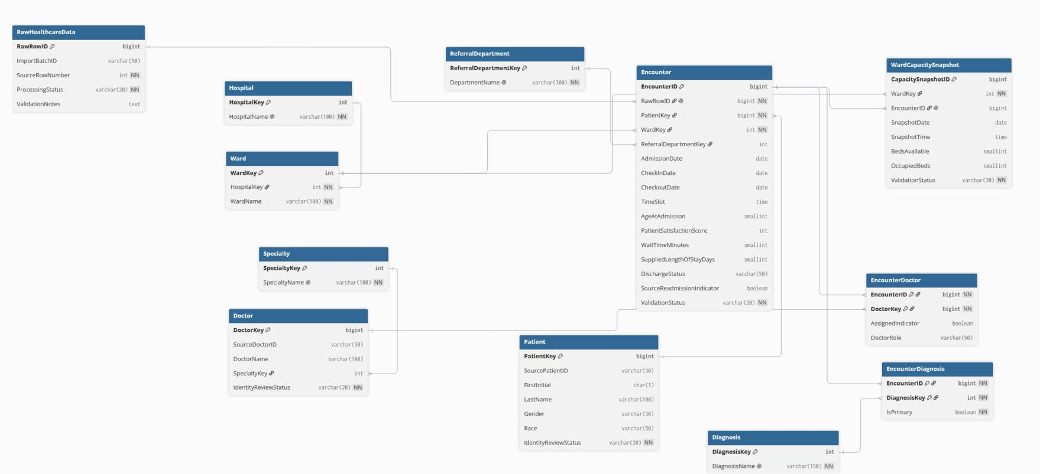
The relational database was designed to Third Normal Form (3NF) to minimise duplication and improve data consistency (Elmasri and Navathe, 2022; Silberschatz, Korth and Sudarshan, 2019). The design established primary and foreign key relationships between entities, while RawHealthcareData was retained to preserve traceability. SQL analysis was used to assess whether the proposed structure could support the organisation's reporting requirements.

Figure 1: Final logical Entity Relationship Diagram

AI-Assisted Python Profiling, Missingness and Cleaning
Gemini in Google Colab assisted with Python/Pandas profiling code, which was executed against the complete dataset to assess dimensions, data types, missing values, duplicates and internal consistency.
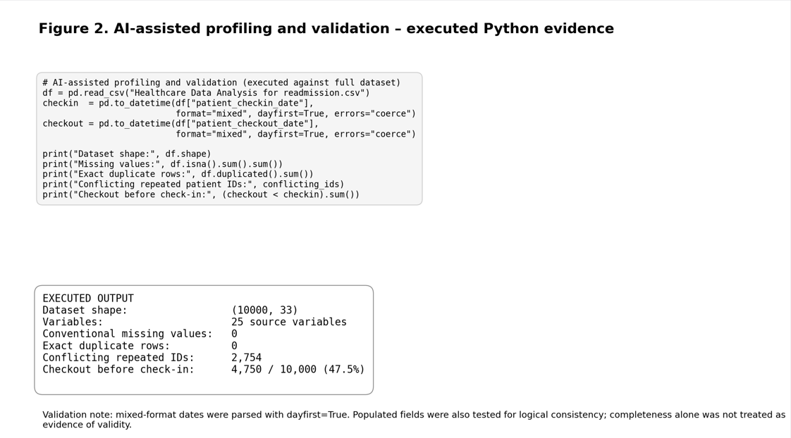
Initial profiling found 26 variables, no conventional missing values and no exact duplicate rows. Missing data were assessed by data type and content, recognising that populated values may still be analytically unusable; date fields therefore underwent conversion and logical validation. Further checks showed that completeness alone did not indicate data quality. Analysis identified 2,754 repeated patient identifiers associated with conflicting demographic information. In addition, 47.5% of records contained a checkout date earlier than the corresponding check-in date. Comparison of the supplied and date-derived length-of-stay fields also identified substantial inconsistencies, demonstrating the need to validate calculated measures before analytical use.
Figure 2: Google Colab output showing AI-assisted Python profiling and validation

Cleaning was deliberately conservative: source values were not replaced unless the correct alternative could be established. Conflicting demographics were not resolved by selecting the most frequent value, and invalid date sequences were not automatically reversed. Records were classified as VALID, WARNING or QUARANTINED according to validation severity, preserving transparency and avoiding unsupported automated corrections.

AI-Assisted Feature Engineering and Validation
AI supported identification of derived variables, with candidate features retained only where they addressed the business requirement.
A key engineered measure was Derived Length of Stay, calculated from valid check-in and checkout dates. Retaining both the original and derived values enabled discrepancies to be identified rather than hidden through automatic replacement.
AI-supported feature engineering produced new record-level variables including DerivedLengthOfStay, LOSDiscrepancy and ValidationStatus. Capacity information was also used to derive occupancy measures where the underlying values satisfied the required validation rules. These engineered features were subsequently combined with existing source variables to produce higher-level analytical measures, including average waiting time, ward encounter volume, diagnosis activity and the supplied readmission indicator. Distinguishing engineered features from aggregated measures ensured that the transformation process remained transparent and reproducible.
Validation rules were applied before calculated features were accepted. These included checks for chronological consistency between check-in and checkout dates, agreement between supplied and derived length of stay, consistency of repeated patient demographics and plausible ward-capacity values. Derived Length of Stay was calculated only where checkout occurred on or after check-in, while capacity calculations excluded logically impossible observations, such as occupied beds exceeding available beds. These observations were retained as data-quality exceptions rather than automatically corrected.
This distinction is important because feature engineering can otherwise amplify errors already present within a source dataset. AI therefore assisted in identifying and generating transformations, but deterministic validation rules controlled which observations contributed to analytical measures. This reflects the complementary relationship between automated methods and data-management validation described by Dong and Rekatsinas (2018). Validation classified 66 records as VALID, 5,184 as WARNING and 4,750 as QUARANTINED.

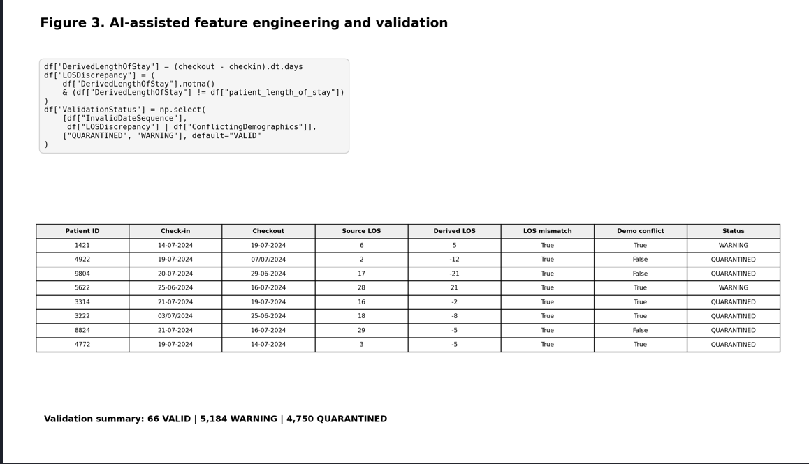
Figure 3: Python output showing engineered variables and validation results

Analytical Findings and Interactive Dashboard
SQL analysis was used to demonstrate that the relational structure could answer the original business questions. Source-level execution identified 4,142 records marked positively by the supplied readmission field, equivalent to 41.42% of the 10,000 records. The ward-level totals reconciled with the complete source dataset.
The term source readmission indicator was retained throughout the analysis because the dataset does not define a clinical readmission period. It would therefore be inappropriate to describe the value as a clinically validated 30-day readmission rate.
An interactive Power BI dashboard was developed to translate the analytical outputs into information suitable for non-technical users. The dashboard incorporated headline measures for total hospital activity, the source readmission indicator, average valid length of stay, average waiting time and hospital-capacity utilisation. Supporting visualisations enabled comparison of activity and analytical measures across wards, diagnoses and other relevant groups.
Preference slicers were implemented for ward, diagnosis, specialty, referral department and selected patient characteristics. Cross-filtering enabled users to select a particular category and dynamically update the corresponding KPI measures and visualisations. This allowed users to move from an organisation-level overview to specific populations or operational areas according to their analytical requirements.

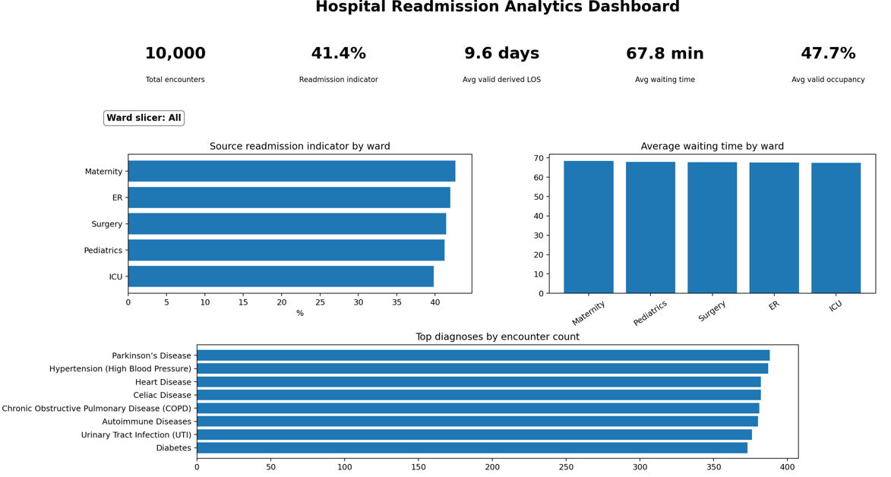
Figure 4: Power BI dashboard – complete unfiltered view
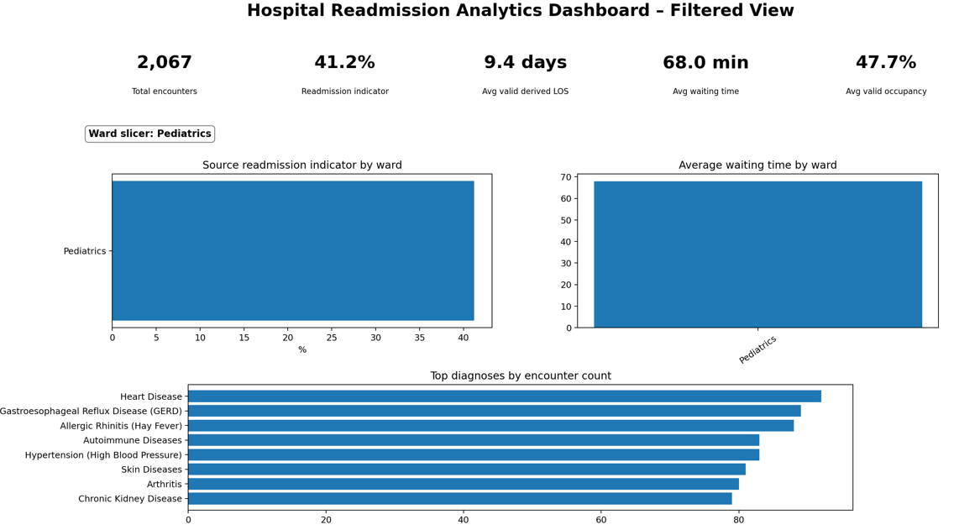
Figure 5: Power BI dashboard – filtered view demonstrating interactive preference filtering

AI supported the analytical and visualisation process by assisting with the identification of appropriate measures and potential visual representations. AI-supported visualisation can assist with several stages of the visualisation process, although human involvement remains important in determining whether the resulting representation is appropriate for its intended audience (Wu et al., 2022).
The dashboard provided exploratory decision support rather than definitive clinical conclusions. Although its indicators were useful for identifying patterns, substantial data-quality exceptions limited their reliability. Ward and diagnosis comparisons should therefore prompt further investigation rather than be interpreted as evidence of causality or validated clinical performance.

Legal, Ethical and Information-Governance Requirements
Although the project used a publicly available academic dataset, applying the solution to real healthcare information would require considerably stronger information-governance controls.
In a real UK healthcare environment, patient health information would constitute special-category personal data under the UK GDPR and would also fall within the UK data-protection framework established by the Data Protection Act 2018. Processing would therefore require an appropriate lawful basis and relevant condition for processing special-category information, alongside organisational information-governance requirements.
The UK GDPR requires personal information to be processed according to principles including lawfulness, fairness and transparency; purpose limitation; data minimisation; accuracy; storage limitation; integrity and confidentiality; and accountability (ICO, 2026a).
These requirements have implications for both the relational database and the AI component. Only information necessary for the defined analytical purpose should be processed, and identifiable information should not be made available to users who do not require it. Appropriate measures would include role-based access, pseudonymisation where appropriate, audit logging, secure storage and transfer, retention controls and regular review of access.
The security principle also requires organisations to implement technical and organisational measures appropriate to the level of risk (ICO, 2026b). For healthcare analytics, this would include protecting the confidentiality, integrity and availability of information and ensuring that analytical systems do not inadvertently expose sensitive patient data.
Generative AI introduces an additional governance consideration. Real identifiable patient information should not be submitted to an external AI service without establishing an appropriate lawful basis, processing arrangements, security safeguards and organisational approval. Data minimisation should also apply to AI processing, so only information necessary for the intended task is provided (ICO, 2026c).
Data protection and security should therefore form part of system design from the outset rather than being added after implementation.

Business Findings
From a business perspective, the most important finding was that apparently, complete data could not automatically be assumed to be reliable. Although conventional profiling identified no missing values, deeper validation revealed conflicting patient information and substantial inconsistencies in dates and length-of-stay data. If these issues were not identified and appropriately managed before reporting, they could distort performance indicators presented to hospital managers and potentially lead to incorrect conclusions about patient activity or service performance.
The findings therefore indicate that a healthcare organisation should not move directly from raw data to dashboard reporting. Validation, traceability and clearly documented transformation rules are necessary to establish whether an indicator can reasonably be relied upon.
AI provided value by accelerating schema exploration, code generation and identification of analytical opportunities. However, the project also demonstrated why AI output requires verification. Suggestions that appeared reasonable, such as selecting the most frequent demographic value when records conflicted, could not establish which source value was genuinely correct.

Prioritised Recommendations and Conclusion
Priority 1 – Data quality: The first priority is to strengthen data quality before operational use. Invalid date sequences, conflicting demographic information and discrepancies in length of stay should be investigated before affected records contribute to decision-making.
Priority 2 – Database implementation and traceability: The second priority is to implement the normalised database with complete source traceability. The original data should remain available as an immutable staging layer, while generated identifiers and validation statuses enable processed records to be traced back to their source.
Priority 3 – AI validation and governance: AI-assisted processing should operate within a documented validation framework. Generated code should be reviewed and tested, cleaning rules should be reproducible, and significant inconsistencies should be quarantined rather than silently modified.
Priority 4 – Interactive business intelligence: The dashboard should use validated and clearly defined measures. Preference filters should allow users to explore different populations and operational areas, while limitations and excluded records remain transparent.
Priority 5 – Information governance: Information governance should be embedded throughout implementation. UK GDPR requirements, access control, security, data minimisation, retention and governance of external AI tools should be established before real patient information is processed.
In conclusion, the project demonstrated how AI-assisted schema design, Python validation, feature engineering, SQL analysis and Power BI visualisation can support healthcare analytics. However, the substantial data-quality issues identified highlight the importance of human oversight, reproducible validation and information governance. The proposed solution provides a foundation for improved hospital reporting, but further data-quality improvements and validation are necessary before its outputs can reliably inform operational decisions.

References
Dong, X.L. and Rekatsinas, T. (2018) ‘Data integration and machine learning: A natural synergy’, Proceedings of the 2018 International Conference on Management of Data (SIGMOD '18). New York: Association for Computing Machinery. doi: 10.1145/3183713.3197387.

Elmasri, R. and Navathe, S.B. (2022) Fundamentals of Database Systems. 7th edn. Harlow: Pearson Education Limited.

Information Commissioner’s Office (ICO) (2026a) A guide to the data protection principles. Wilmslow: Information Commissioner’s Office.

Information Commissioner’s Office (ICO) (2026b) A guide to data security. Wilmslow: Information Commissioner’s Office.

Information Commissioner’s Office (ICO) (2026c) Guidance on AI and data protection. Wilmslow: Information Commissioner’s Office.
Sharma, P. (no date) Hospital Data for Patient Readmission Prediction: Predicting patient readmissions using hospital visit data. Kaggle. Available at: Kaggle (Accessed: 22 August 2026).

Silberschatz, A., Korth, H.F. and Sudarshan, S. (2019) Database System Concepts. 7th edn. New York: McGraw-Hill Education.

Wu, A. et al. (2022) ‘AI4VIS: Survey on Artificial Intelligence approaches for data visualization’, IEEE Transactions on Visualization and Computer Graphics, 28(12), pp. 5049–5070. doi: 10.1109/TVCG.2021.3099002.

